MINISTRY OF JUSTICE INFORMATION OFFICE OF THE NATIONAL CRIMINAL REGISTER
SEX OFFENDERS REGISTER INFORMATION SYSTEM
RESTRICTED ACCESS REGISTER - USER MANUAL FOR INDIVIDUAL ACCOUNT
Version 1.0

I. Table of contents
I. Table of contents 1
1 Introduction 2
1.1 Commonly used terms 2
1.2 The purpose of this document 2
1.3 Use of E-services Application 2
2 Individual User Account 3
2.1 Account Registration 3
2.2 Signing in and password reset 8
2.3 Account management 10
2.4 Acquiring information using Individual Use Account 13
2.5 Queries and information obtained 23
3 Verifying authenticity of printed information 25
II. List of images 28

Introduction
- Commonly used terms
Term, abbreviation | Explanation
The Act | Act of 13th May 2016 on Counteracting the Threats of Sexual Crime
Register | Sex Offenders Register
E-services Application | An application available at www.rps.ms.gov.pl providing SOR System e-services
User | Any person using E-services Application
SOR System | Sex Offenders Register Information System
- The purpose of this document
Pursuant to art. 12 point 8 of the Act, every person is eligible to acquire information whether their data is collected within the Register. This manual explains how to use the Individual User Account in the SOR System thus enabling user to acquire information from the Register.
Note! Checking whether user’s data is collected within the Register is performed within Restricted Access Register and not within the Public Register or the Register of the State Commission. The Public Register concentrates data on the most dangerous sex offenders. To access it user does not need to create an Individual User Account. The Register of the State Commission contains information on persons against whom the State Commission issued a decision concerning entry into the Register. The legal basis for data collecting is the Act of 30th August 2019 on the State Commission for the clarification of cases of activities taken against sexual freedom and propriety towards minors under 15 years of age.

- Use of E-services Application
The E-services Application is available in the internet, through a web browser. User can interact with the application by a computer mouse and a keyboard.
E-services Application provides three types of data-entry fields:
• Descriptive entry-fields, which need to be completed using a keyboard as a ‘name’ field
• Calendar entry-fields, which need to be completed with a fixed date (as in the ‘date of birth’); after clicking a calendar icon user can choose a date – those entry-fields can be completed with a keyboard as well
• Keyboard entry-fields, those fields enable user to enter diacritic characters after clicking the keyboard sign.
Note! User can manually paste any character into descriptive fields using data stored within system clipboard.
It is possible to switch to the high contrast mode, alter the font size or choose the language version (Polish or English) using buttons placed on the top bar of the E-services Application. After clicking Help link it is possible to download user’s manual and terms of use.
By clicking Home page button user can link back to the main page of E-services Application (when signed out) or the main page of their account (after signing in).
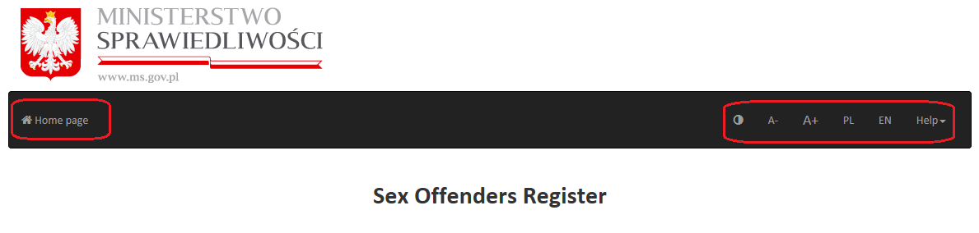
Image 1 E-services Application home page – settings bar: font size, language and help, back to home page link

Note! E-services Application uses ‘cookies’. They help to identify user and improve application’s functioning. In the browser settings it is possible to turn them off but some of E-services Application features may be affected. ‘Cookies’ do not containt any personal data.

Individual User Account
  - Account Registration

Checking whether user’s data is collected within the Register is only possible after creating an Idividual User Account.
In order to create an Individual User Account, user needs to choose Create an account button available in the Restricted Acces Register menu at E-services Application home page.
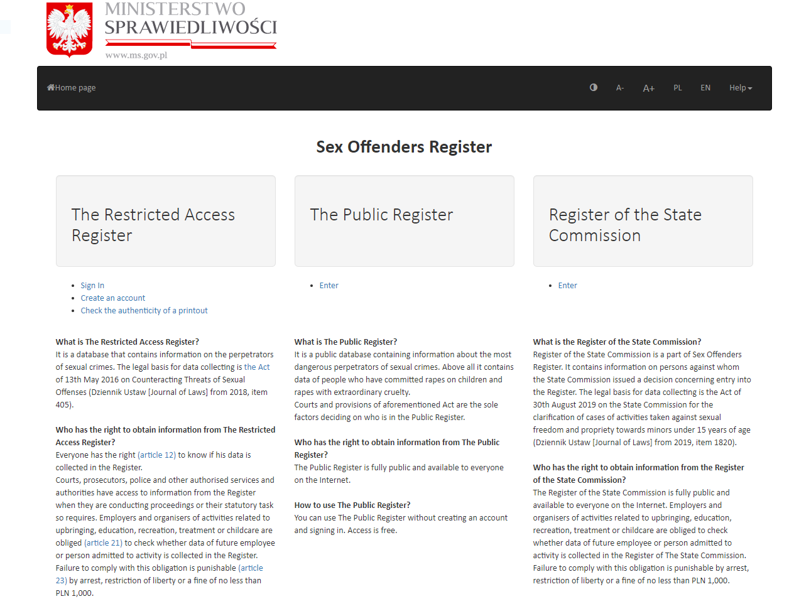
Image 2 E-services Application home page

Next screen shows addtitional information for users who want to create an account. There the user needs to choose Create an account button.
Note! Registration form is not case-sensitive. While creating an account the size of letters does not matter – for example the name ‘Peter’ can be given as ‘peter’ ‘PETER’ or ‘Peter’. Further use of E-services Application will not be affected by the way the registration data was given.
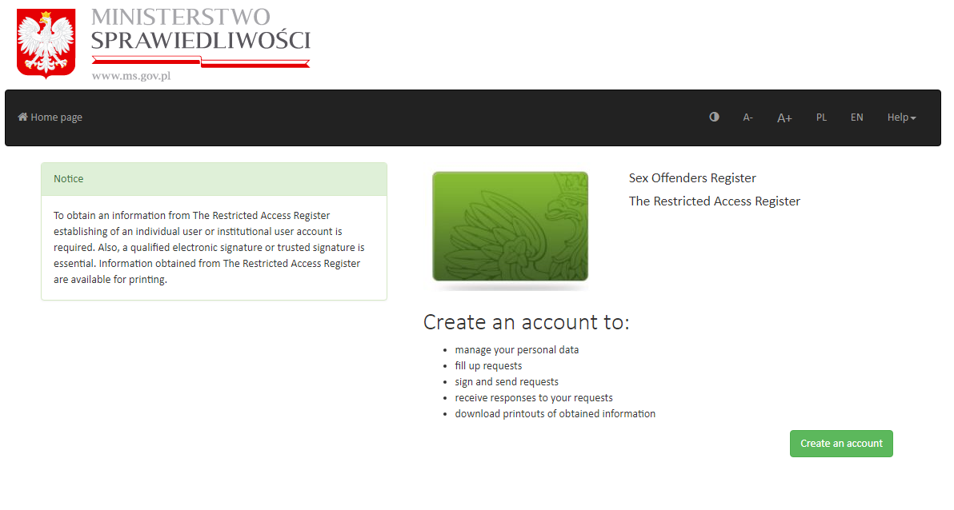
Image 3 Restricted Access Register main page

When the registration form is displayed user needs to choose the type of an account (a – see image nº 4). After that all of the obligatory entry-fields need completing in the Account data section (b – see image nº 4).
Explanation for entry-fields:
- Name – obligatory field, needs to be completed with data in accordance with the actual state and data contained in the qualified electronic signature certificate or in the Trusted Profile (Profil Zaufany) or in the personal signature certificate
- Surname – obligatory field, needs to be completed with data in accordance with the actual state and data contained in the qualified electronic signature certificate or in the Trusted Profile or in the personal signature certificate
- PESEL number – filling in is obligatory if the PESEL number has been issued
- User ID – obligatory field, user can have their own User ID or let it be generater automatically
- E-mail address – obligatory field, an e-mail address which is used to send a message containing activation link for the Individual User Account to the user
- Re-enter E-mail address – obligatory field, must be completed with e-mail address given in the field above - for confirmation reasons
- Password – obligatory field, user needs to establish a password, which will assure access to the Individual User Account, along with User ID. Password needs to contain at least one capital letter, a digit and a special sign (like !, @,#,$,%,^,& etc.) and has to be longer than 6 characters
- Re-enter password – obligatory field, must be completed with exactly the same phrase given in the field above - for confirmation reasons.
After having the registration form completed, user needs to follow directions given by the Captcha application (c – see image nº 4), wchich is supposed to block attack attempts towards E-services Application by malicious software.
Moreover, when creating an accout it is required to:
- acknowledge consulting terms of use of the SOR System (available to the user after clicking Terms of use button)
- agree to have personal data processed by marking appropriate boxes within the registration form (d – see image nº 4).
After that it is possible to choose Create an account button.
If there is anything missing in the registration form, creating of an account will be impossible – Create an account button will remain inactive.
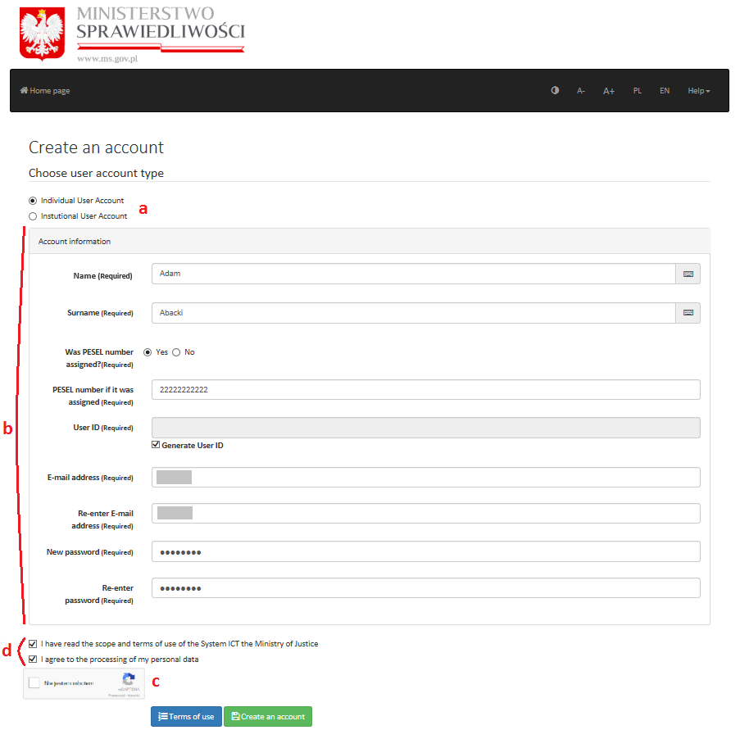
Image 4 Individual User Account registration form

After submitting registration form, user is directed to home page showing a pop-up message about sending an activation e-mail to the address given in the registration form.
Signing in is possible only after clicking the activation link in the e-mail message mentioned above.
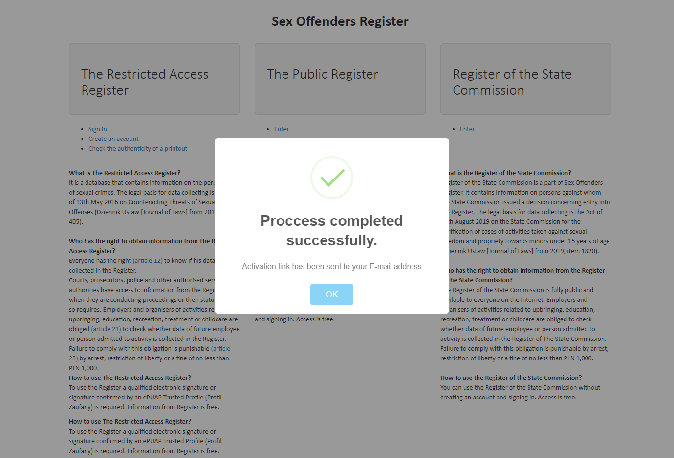
Image 5 Registration process successful

  - Signing in and password reset

After account activation it is possible to sign in to the Individual User Account. Sign in link is available on the E-services Application home page (rps.ms.gov.pl).
In order to sign in the user must fill in their User ID and password and then choose Sign in button.
E-services Application Administrator may sometimes publish important information concerning Application or the SOR System. They will be displayed on signing in screen.
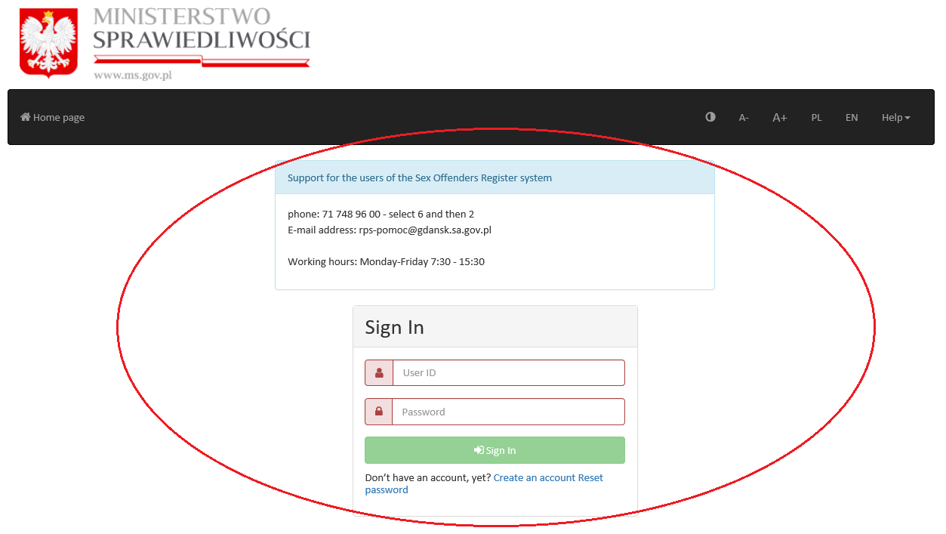
Image 6 Signing in and an example of message from E-services Application Administrator

In case user forgot their password, it is always possible to reset password by clicking Reset password button available on signing in screen.
To reset a password user needs to fill in their User ID (it is mentioned in the first activation e-mail sent just after creating the accout, in case user forgot their ID), e-mail address given at account registration and additionally needs to follow directions given by Captcha application. After that Reset password button becomes active. Clicking it causes system to send an e-mail containing link enabling user to change their password.

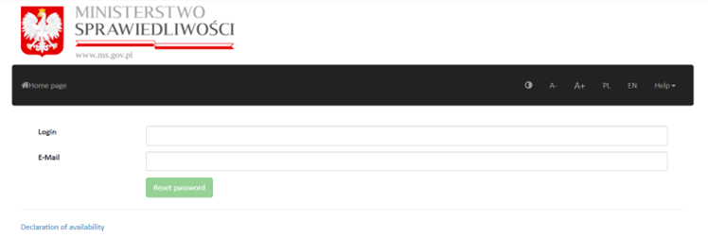
Image 7 Password reset

After signing in to the e-mail account, user needs to click the mentioned link. In the form displayed on the screen user needs to give new password and then re-type it to confirm it. To complete resetting password user needs to choose Save (Zapisz) button. After that it is possible to sign in to the individual user account with new password.
Note! Signing out is described in Account management (see pt 2.3).
  - Account management

After signing in to the account, on the right of the top bar there is a menu available under User ID name. To activate the menu user needs to click the button with User ID.
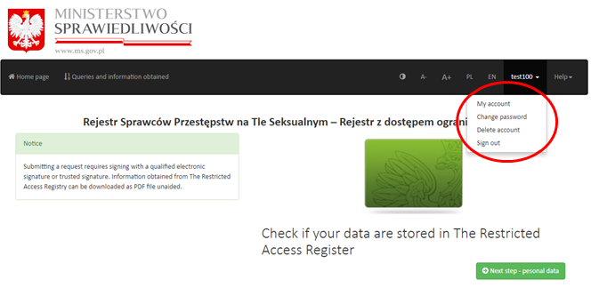
Image 8 Account management
List of available options:
- My account
- Change password
- Delete account
- Sign out
In My account user can check and modify personal data that were registered. In order to make changes user needs to fill in the appropriate field with new data and click the Save button.
Note! It is important that all the personal data are consistent with data stored in the qualified electronic signature certificate or in the Trusted Profile or in the personal signature certificate
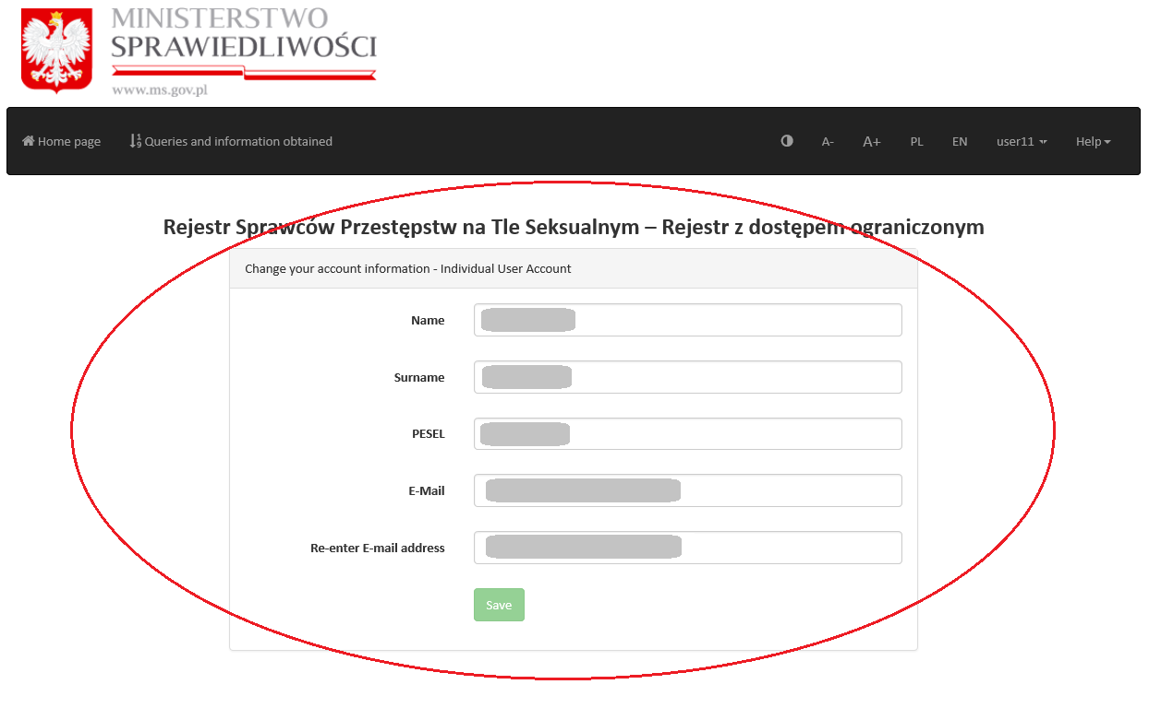
Image 9 My account

In Change password user can set a new password for their Individual User Account by filling in the appropriate fields with previous password, new one and repeating the new password. After that user needs to click on the Save button.
At the next sign in user needs to give their new password.
Note! System checks whether previous password is correct and the new one meets requirements for a password.
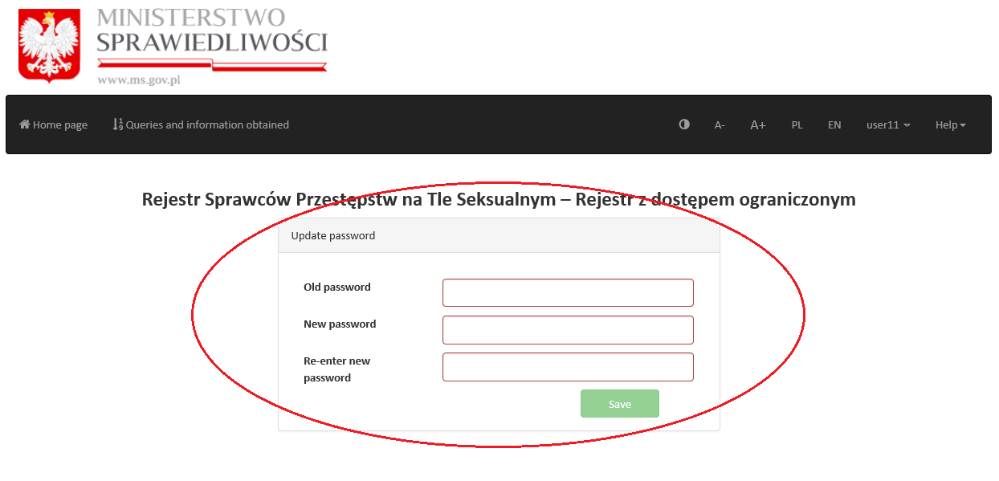
Image 10 Change password
Clicking on Delete account shows a message ‘Are you sure you want to remove the account?’. User can abort operation (by clicking Back) or confirm it (by clicking Delete).
Note! Deleting an account causes loss of access to the account, including information acquired so far by the user with E-services Application form the SOR System.

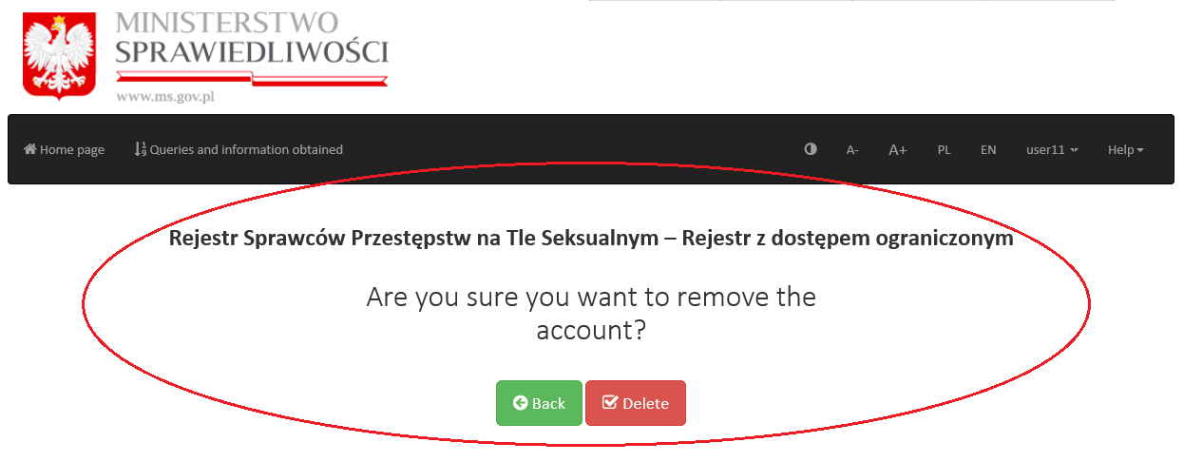
Image 11 Delete account
The last option in the menu under the User ID is Sign out. Choosing this option causes immediate log out operation. To further operate within their account user needs to sign in again.
Note! Automatic sign-out occurs after 15 minutes of inactivity in order to keep user’s personal data and information acquired from the E-services Application safe.
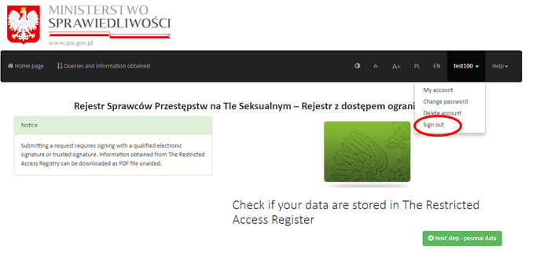
Image 12 User sign out

  - Acquiring information using Individual Use Account

When signed in ont their E-services Application Individual User Account user can generate queries to the SOR System. Sending a query requires signing it with a qualified electronic signature or the trusted signature or a personal signature. Acquired information can be printed.
In order to generate and then send a query user needs to click on Next step – personal data button which can be seen on the Individual User Account home page.
Image 13 Next step – personal data
Next, a query form needs completing. According to the Act, a natural person is only eligible to obtain information from the Register concerning their own self. Hence some of the data needed for the query are automatically preloaded from the personal data given during registering of the Individual User Account. Additionally user is required to fill in the following entry-fields (a – see image nº 14):
- Family name
- Father’s name – if it is unknown, this field should be completed with phrase - brak danych
- Mother’s name
- Date of birth
After completing the form it is important to reassure that all the data were given correctly and that they are actual and authentic. The search in the Register is held based on the data given in the query form.
By clicking Back user can go back to previous screen of E-services Application (b – see image nº 14).
There is also a Clear button available to the user (c - see image nº 14), wchich enables user to erase all the user-given data within the query form.
When the query form is complete it is necessary to sign it – signing screen will be displayed after clicking Nex step – signature (d - see image nº 14).
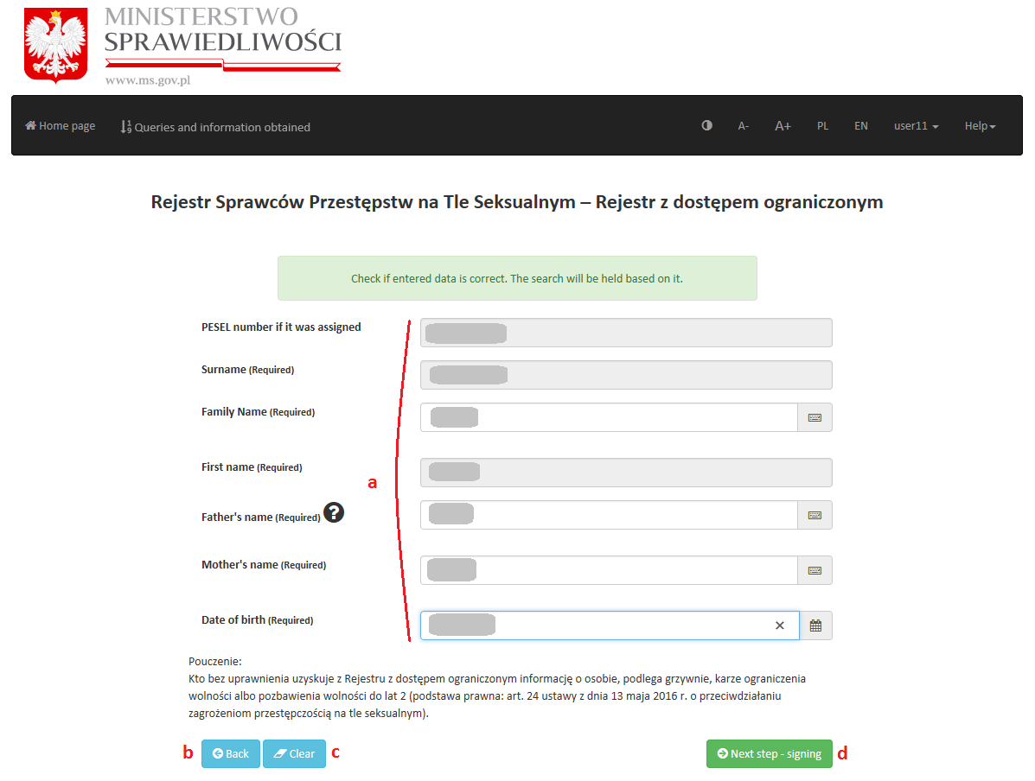
Image 14 Query form
In order to sign the query user needs to choose between three available methods of signing:
- Trusted Profile
- Qualified signature
- E-document
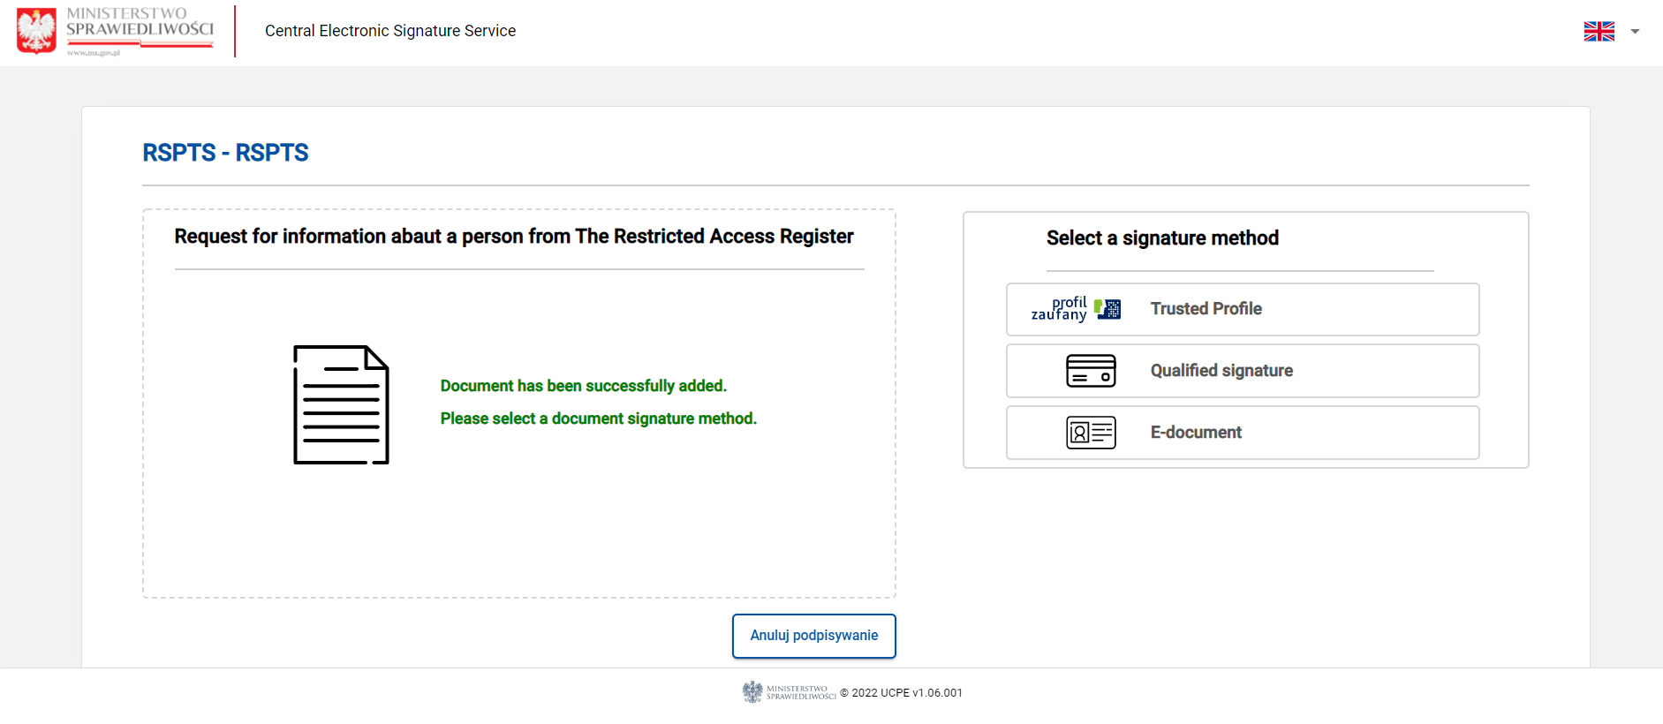

Image 15 Signing screen

Further instructions for qualified signature or e-document:
Before signing a query with a qualified signature or e-document:
- user’s device must have an updated version of JAVA runtime environment installed (see page https://java.com);
- user’s browser must have a dedicated SZAFIR SDK WEBMODULE extension installed – this concerns only Firefox, Chrome, Opera and Safari browsers (Internet Explorer does not need that extension)
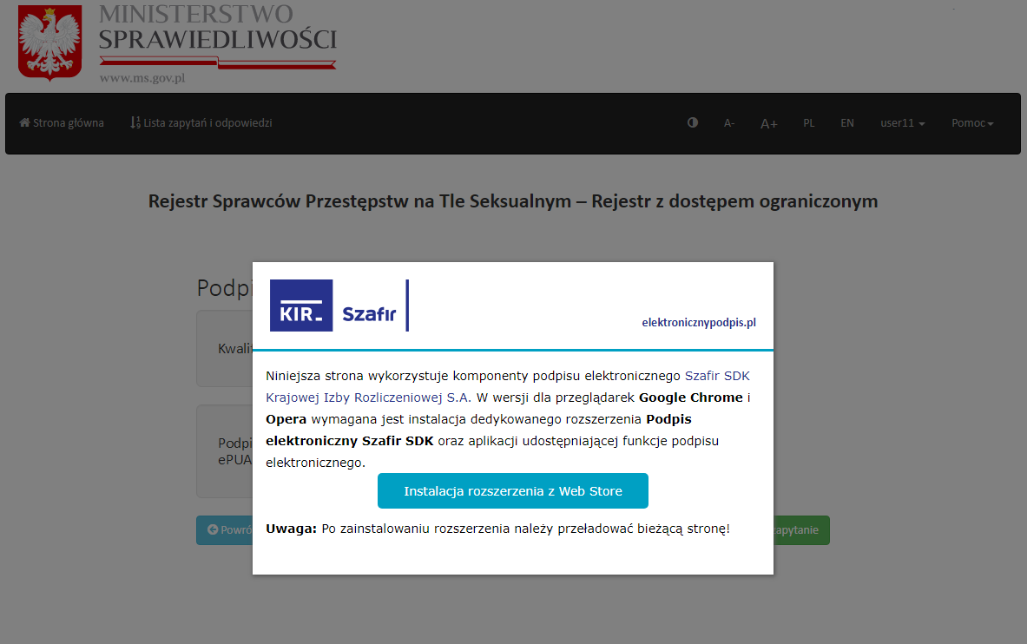
Image 16 SZAFIR SDK WEB MODULE extension installation
- user’s device must have a SZAFIR HOST software installed;
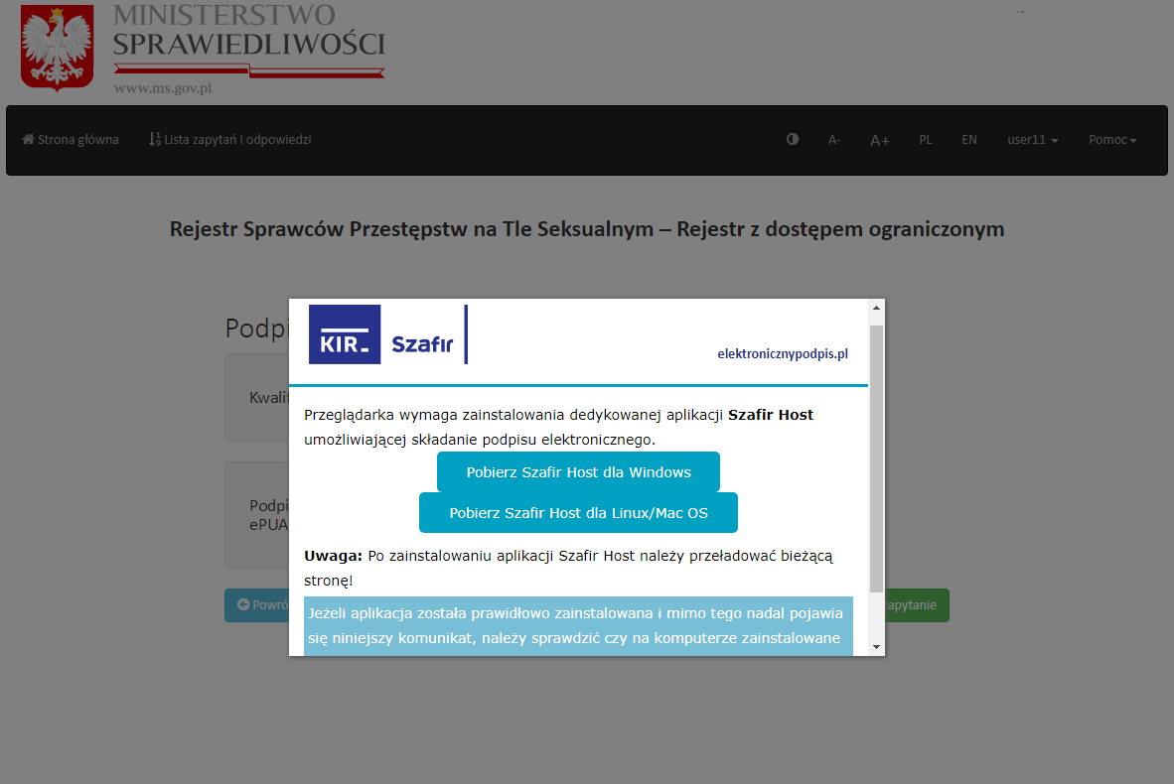
Image 17 SZAFIR HOST installation
Installation of both SZAFIR HOST and SZAFIR SDK WEB MODULE is enabled automatically when the first signing attempt occurs (after clicking on Qualified signature or E-document button).
If the signature by means of E-document is selected:
Additionally, signing an inquiry with the use of e-proof requires prior installation of e-proof software. The required software is available for download at https://www.gov.pl/web/e-dowod. On the website you can find information on how to obtain an ID card with an electronic layer and how to use an e-ID.
After installation of additional software it is possible to sign the query. Clicking Qualified signature or E-document enables signing applet. Afterwards user should review the contents of the query, then needs to choose the appropriate certificate and click Sign button.
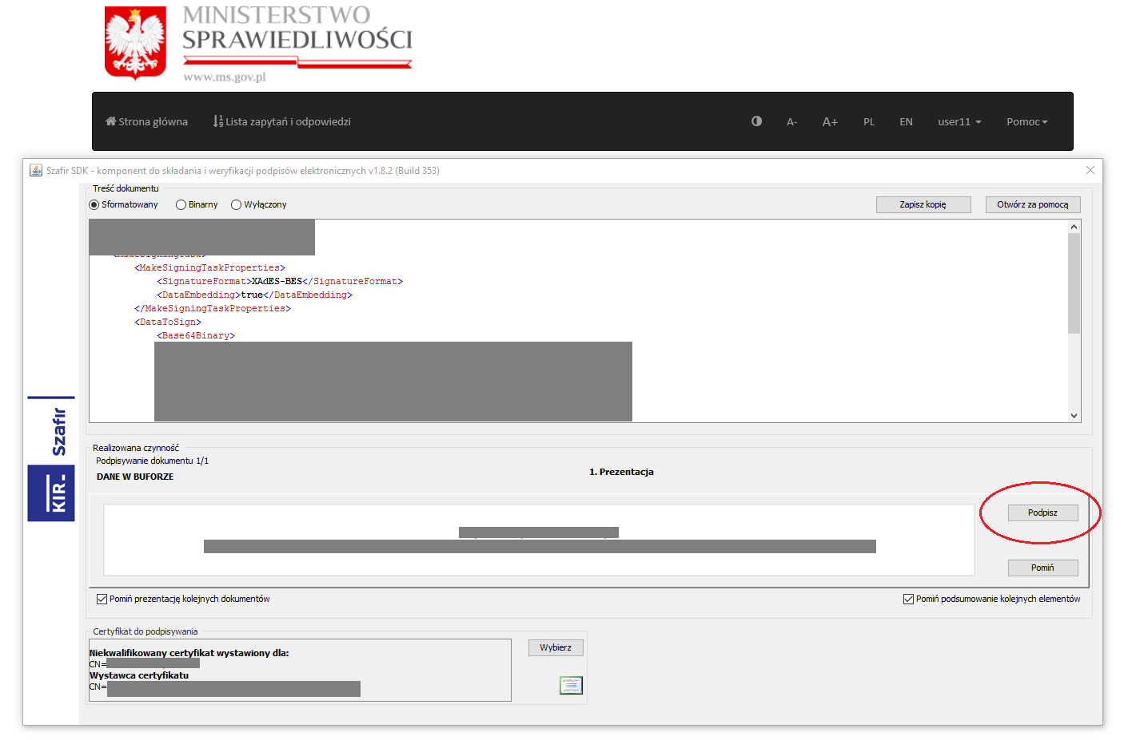
Image 18 Qualified electronic signature – signing applet

Singing operation must be authorised by filling in the PIN number and then clicking Akceptuj button.

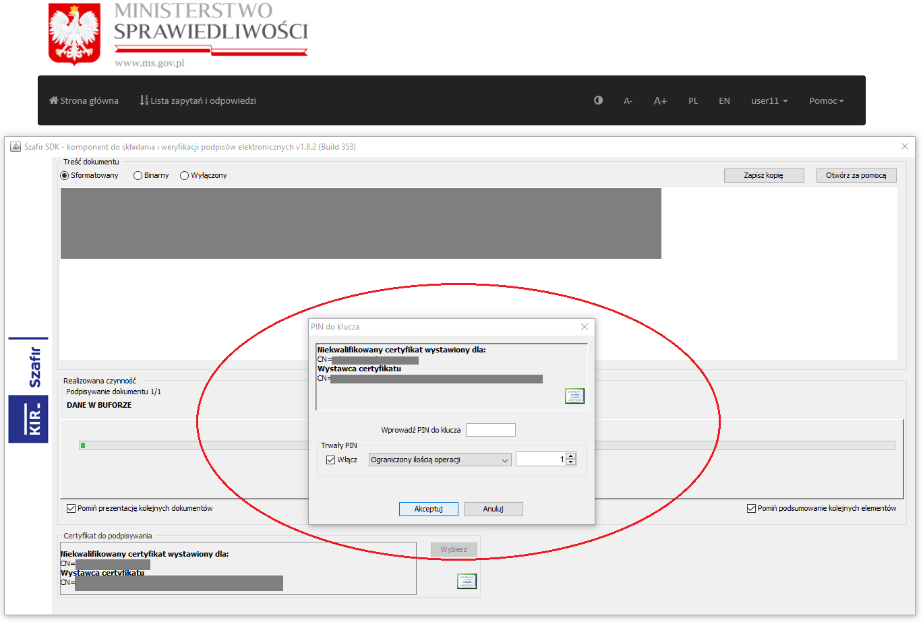
Image 19 Authorising with PIN number
If PIN number is correct, signing operation is over. User needs to click Zakończ button to be able to send the signed query.
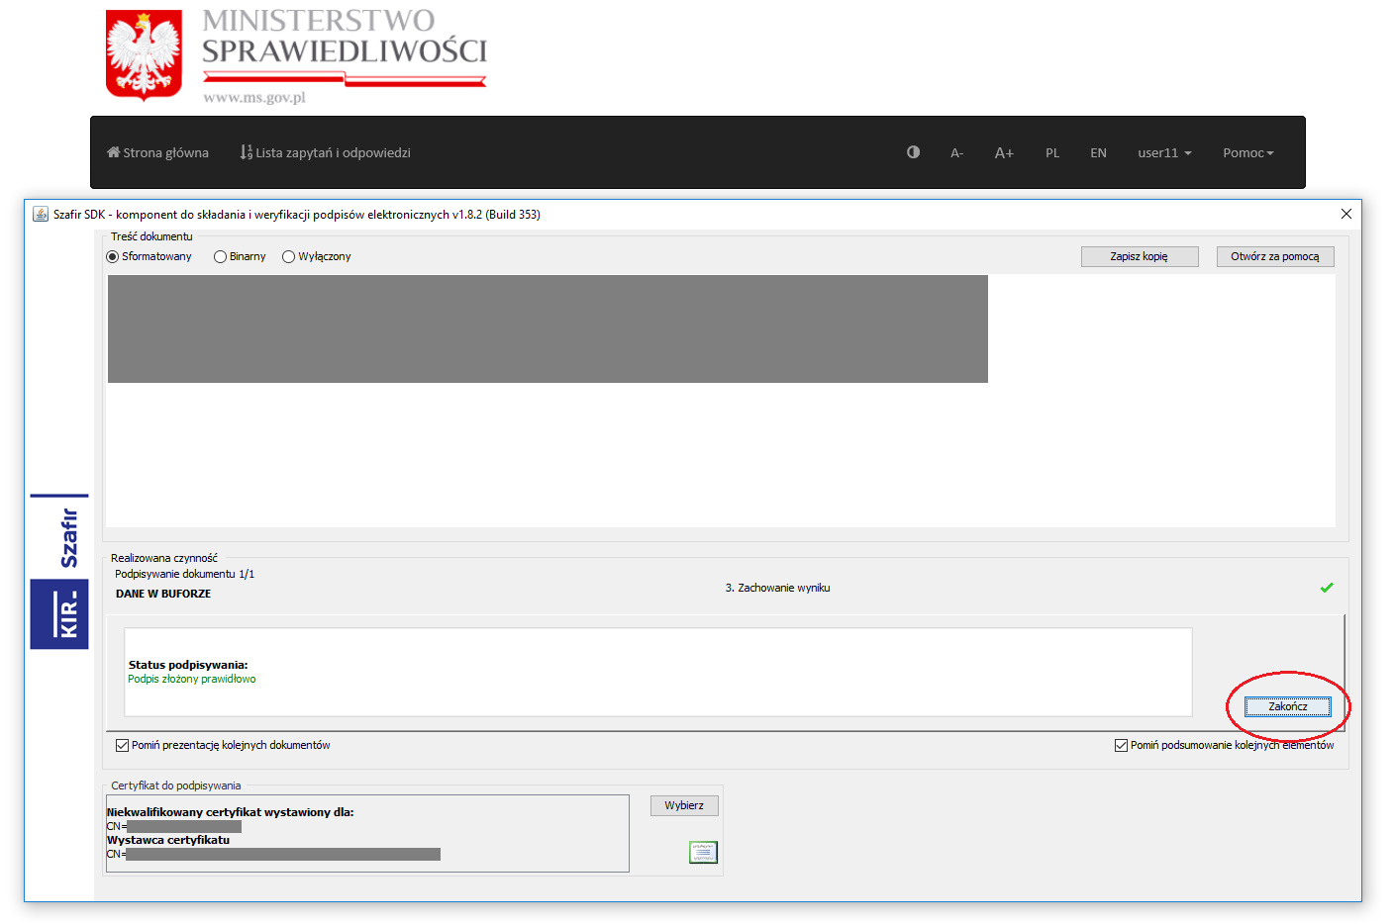
Image 20 Signing operation completed

Further instructions for Trusted Profile:
After clicking Trusted Profile a sign in screen is displayed. User needs to sign in with their credentials and clicking Zaloguj mnie button.

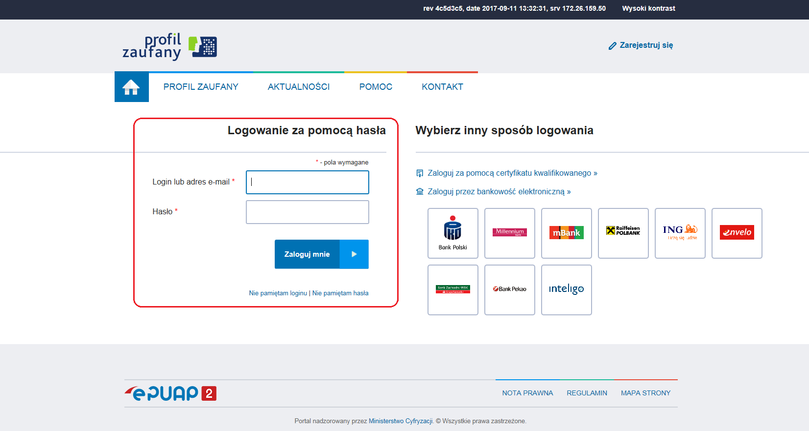
Image 21 Trusted Profile (Profil Zaufany) signature – sign in

The next screen enables user to download and check the query with Pobierz dokument button (a – see image nº 22) and sign the query using Podpisz podpisem zaufanym button (b - see image nº 22).
Image nº 23 show an example query downloaded using Pobierz dokument button.
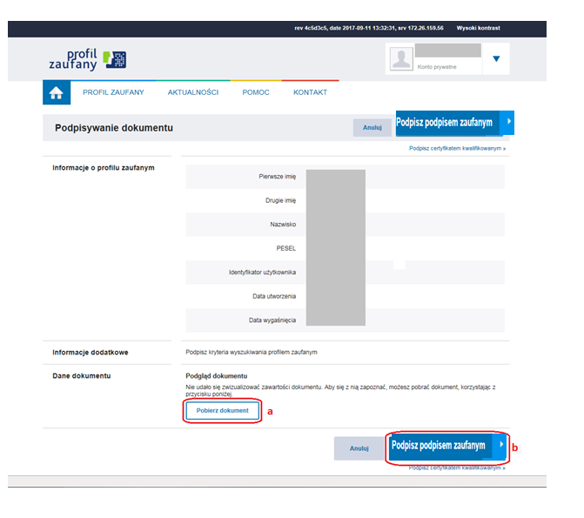
Image 22 Trusted Profile (Profil Zaufany) signing

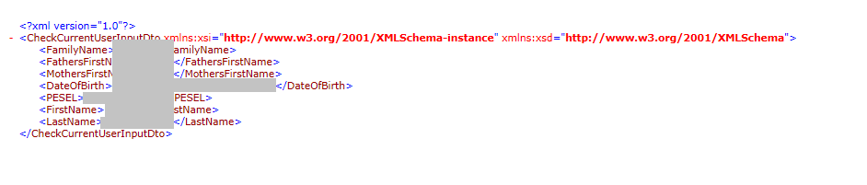
Image 23 Query example

After clicking Podpisz podpisem zaufanym button, an authorisation screen will be displayed. User needs to enter a one-time transaction code sent to their SMS device and then click Autoryzuj i podpisz dokument button. If the code is correct, the query is signed, and user is redirected back to E-services Application.
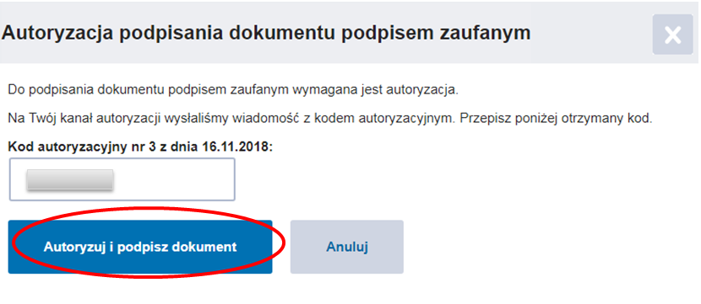
Image 24 Authorising signature with Trusted signature

When signing process is complete Send request button becomes active. Clicking it will send the query to the SOR System and afterwards the information from the Register will be displayed.
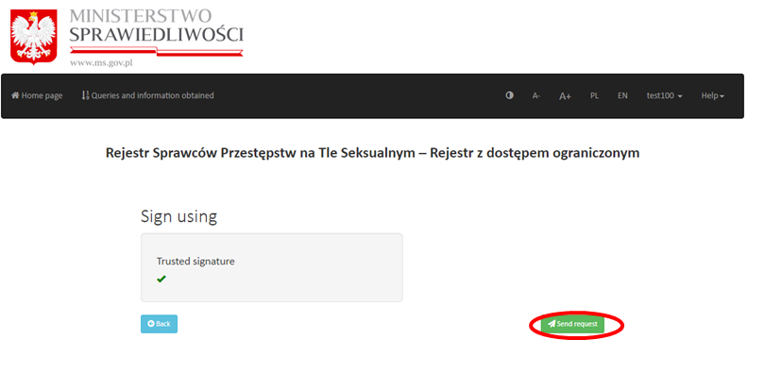

Image 25 Sending query

Note! Waiting time for response from the SOR System varies depending on current system load.
When the information from the Register is displayed user can click Back button (a – see image nº 19) which can be useful when there is a need to correct the data in the query. Choosing this button will lead back to the query form.
Moreover there is a possibility to download a printed version of information – under Get PDF file (b – see image nº 19) button. PDF printout contains the same information as that given directly from the Register.
Information obtained from the Register and PDF printout consists of the repeated data that was given in the query. Moreover there is one of the informations given below:
- ‘FIGURES’ – means that data of the person mentioned in the query was found in the Register and that this data is collected and processed in the Register
- ‘There is no information in the Register about the persons for whom the terms of the request are fulfilled’ – means that data of the person mentioned in the query was not found in the Register and that such data is not processed in the Register
- ‘There is ongoing proceeding to determine correct data. Obtaining information will be possible after it is completed’ – means that for the data given in the query a formal proceeding is conducted and that obtaining information is not possible until the proceeding has ended. In such case it is advised that the user repeats the same query later. If obtaining the conclusive information from the Register is an urgent matter or if the same response from the Register has been obtained for several times in longer period of time it is advised to write to the Information Office of The National Criminal Register. The submission should contain all the data given in the query form or the printed information from the Reigster attached. Submissions should be sent by post to:
Biuro Informacyjne Krajowego Rejestru Karnego
(Information Office of The National Criminal Register)
ul. Czerniakowska 100
00-454 Warszawa
The PDF printout has a unique ID which enables to check authenticity of the printout.
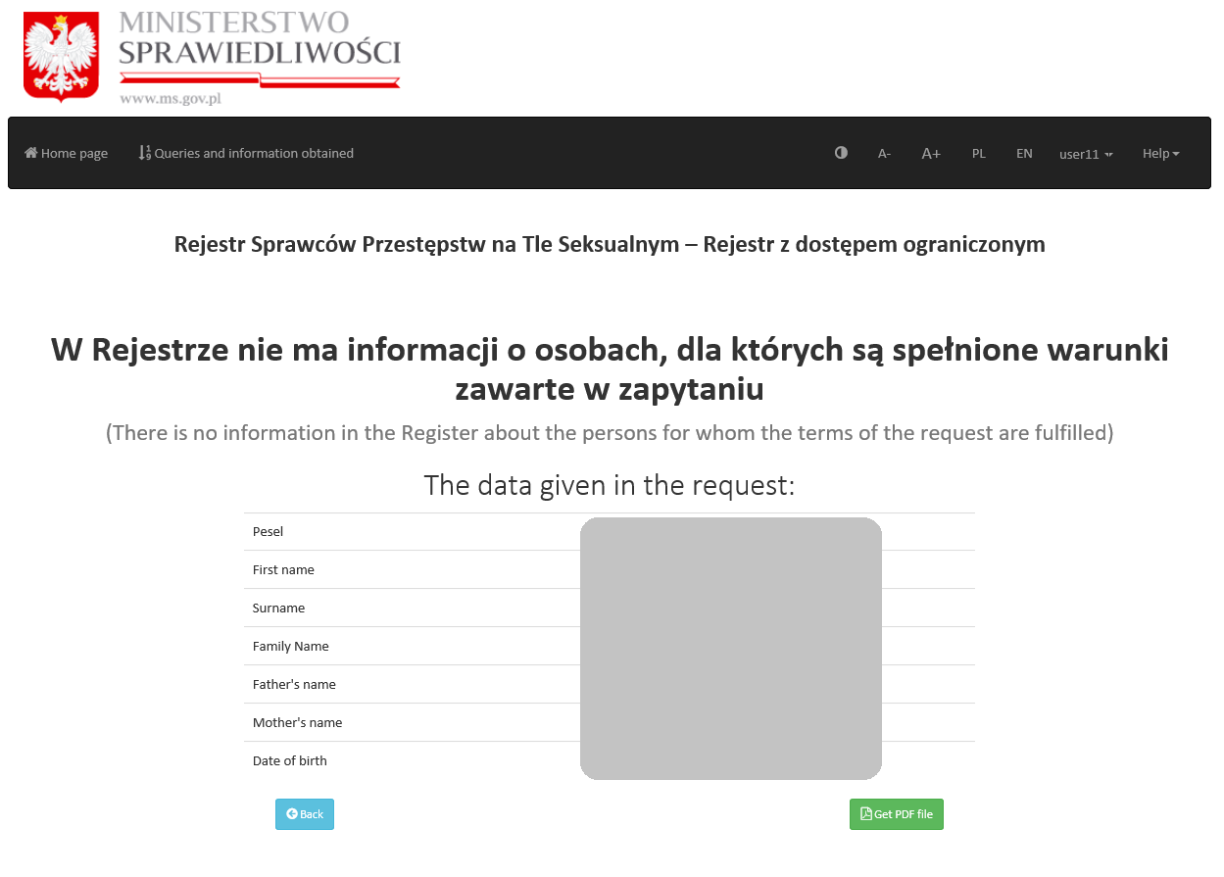
Image 26 Information obtained from the Register – response screen

  - Queries and information obtained

Queries sent to the SOR System as well as information obtained from the Register are available to the user in the E-services Application in the Queries and information obtained list.
To access the list user needs to choose the button visible on the top bar.
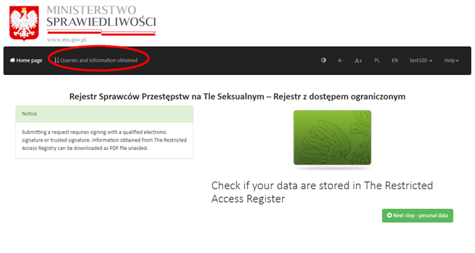
Image 27 Queries and information obtained - link

When the list is displayed user can browse all the information and download responses.
Queries and information obtained is a chart with headlined columns:
- Date of the information – this column shows the date of the response from the Register
- PDF file with information from Register – this column bears the icon of the document. Clicking this icon opens the PDF file with a response from the Register (a – see image nº 21).
Printouts of responses from the Register are always available for the user.
In case there were many queries to the SOR System, the list shows always the newest responses on top of it and the oldest on the bottom. Browsing between older and new responses is also possible by switching pages on the list with Next and Previous button (b see image nº 21).
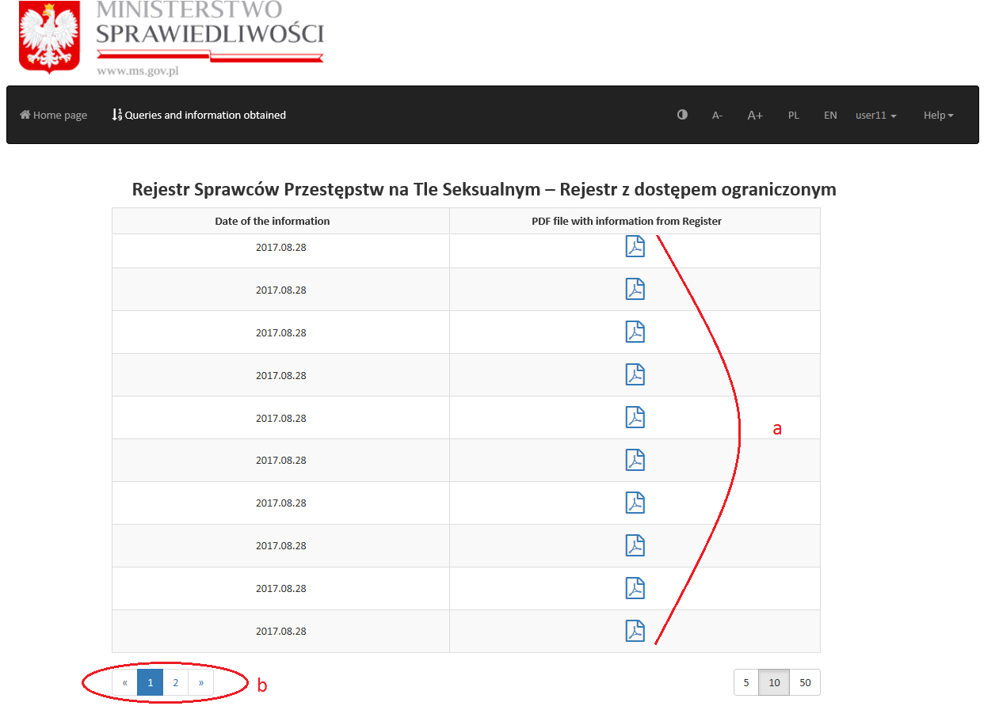
Image 28 Queries and information obtained

Verifying authenticity of printed information

All the printed information from the Register in PDF form (see parts 2.4 and 2.5) bear their unique ID thus enabling user to verify authenticity of the printout.
Verifying authenticity can be useful if there is a need to check whether the printout was generated with E-services Application, and the information it shows originate from the Register.
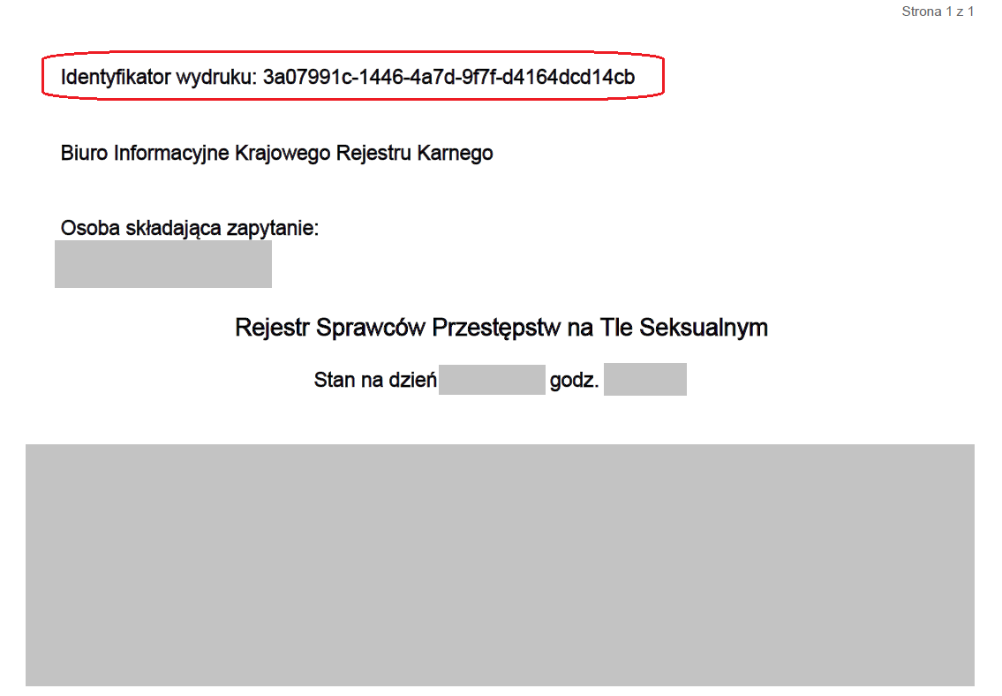
Image 29 PDF printout ID

There is no need to sign in to the account to check authenticity of the PDF printout.
To verify the printout user needs to choose Check the authenticity of a printout button, which is available in the Restricted Acces Register menu at E-services Application home page.
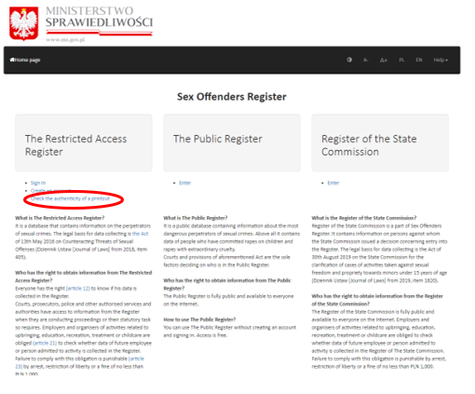
Image 30 Check the authenticity of a printout – home page

When the next screen is displayed, user needs to fill in the PDF printout ID to the appropriate entry-field (ID of a printout) and click on the Check button.
If the user fills in a correct printout ID, E-services Application will open this specific printout thus enabling user to compare both documents.
If the user fills in an incorrect printout ID, E-services Application will show a message ’A printout with given ID numer does not exist in the system‘.
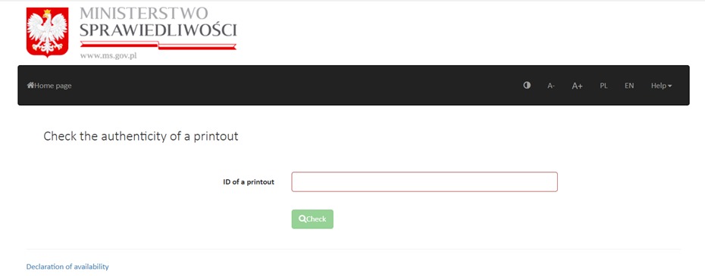
Image 31 Check the authenticity of a printout – filling in the printout ID and checking

II. List of images
Image 1 E-services Application home page – settings bar: font size, language and help, back to home page link 3
Image 2 E-services Application home page 4
Image 3 Restricted Access Register main page 5
Image 4 Individual User Account registration form 7
Image 5 Registration process successful 8
Image 6 Signing in and an example of message from E-services Application Administrator 9
Image 7 Password reset 9
Image 8 Account management 10
Image 9 My account 11
Image 10 Change password 11
Image 11 Delete account 12
Image 12 User sign out 12
Image 13 Next step – personal data 13
Image 14 Query form 14
Image 15 Signing screen 15
Image 16 SZAFIR SDK WEB MODULE extension installation 16
Image 17 SZAFIR HOST installation 16
Image 18 Qualified electronic signature – signing applet 17
Image 19 Authorising with PIN number 18
Image 20 Signing operation completed 19
Image 21 Trusted Profile (Profil Zaufany) signature – sign in 19
Image 22 Trusted Profile (Profil Zaufany) signing 20
Image 23 Query example 20
Image 24 Authorising signature with Trusted signature 21
Image 25 Sending query 21
Image 26 Information obtained from the Register – response screen 23
Image 27 Queries and information obtained - link 24
Image 28 Queries and information obtained 25
Image 29 PDF printout ID 26
Image 30 Check the authenticity of a printout – home page 26
Image 31 Check the authenticity of a printout – filling in the printout ID and checking 27

